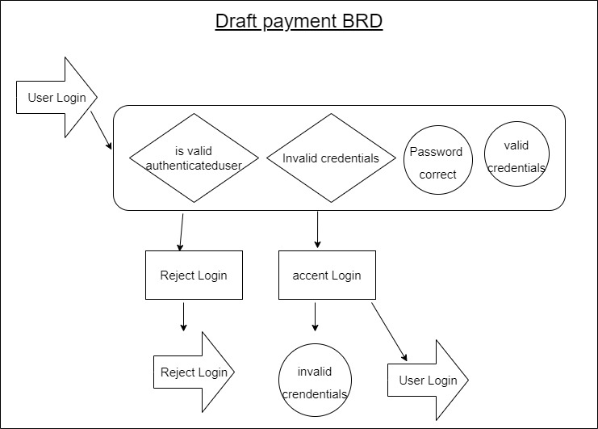

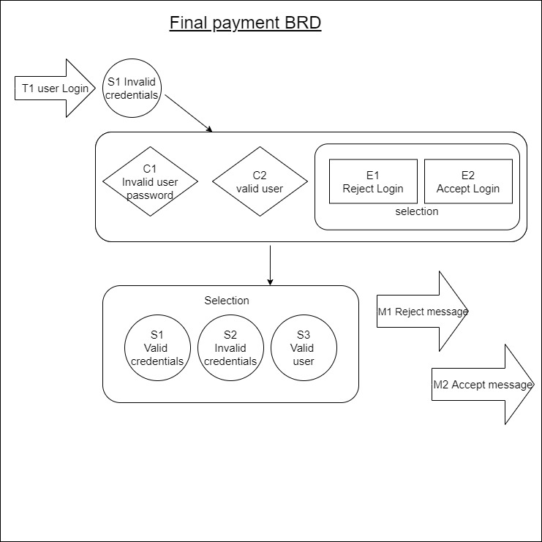

|  |  |  |  |  |  |  |
| --- | --- | --- | --- | --- | --- | --- |
| Event | Trigger | Message | Condition | Pre- state | Post- State | FR/A |
| Reject Login | User Login | Reject message | Invalid User password | Valid Credentials | Valid Credentials | 3.1.1 |
| Accept Login |  | Accept message | Valid User | Valid Credentials | Invalid Credentials | 3.1.2 |
|  |  |  |  | Valid Credentials | Valid User | 4.0.1 |
|  |  |  |  |  |  |  |